**Microprocessor and Computer Architecture**

**UE21CS251B**

**4th Semester, Academic Year 2022-23**

Date: 20/01/23

|  |  |  |
| --- | --- | --- |
| Name: Nikhil Girish | SRN: PES2UG21CS334 | Section:  F |

Week#____1_______ Program Number: ____1___

Title of the Program

**Write an ALP using ARM instruction set to check if a number stored in a register is even or odd. If even, store 00 in R0, else store FF in R0**

1. ARM Assembly Code:

.text

LDR R0,=a

LDR R0, [R0]

ANDS R1,R0,#1

BEQ even

BNE odd

even:

    MOV R2,#0

    B end

odd:

    MOV R2, #255

    B end

end:

.data

a: .word 20

.end

1. Output Screen Shot (Two):

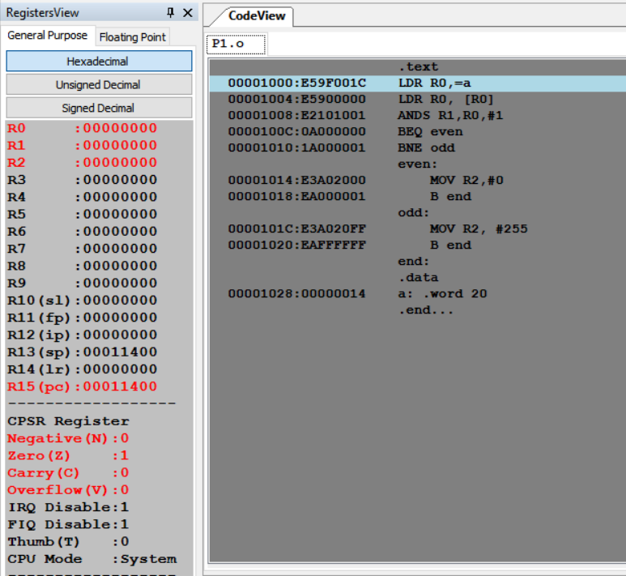

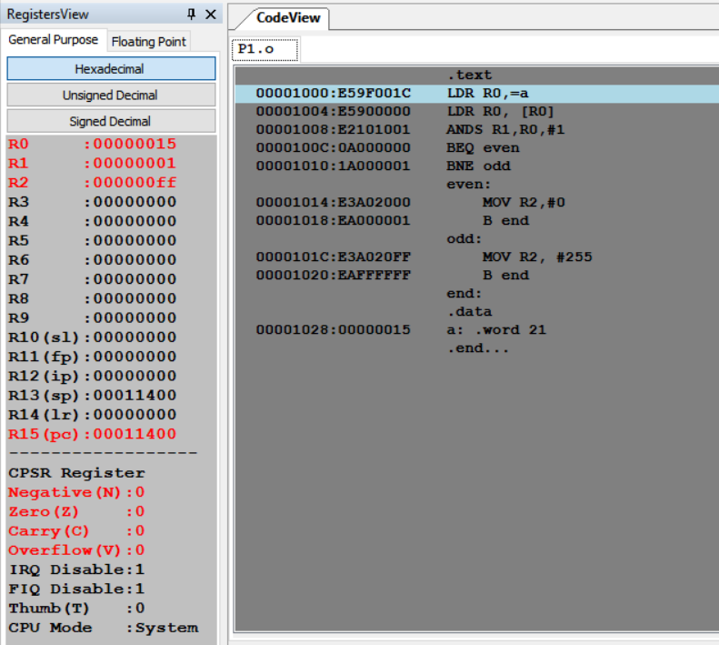

The output should be verified for both even and odd numbers.

**Microprocessor and Computer Architecture**

**UE21CS251B**

**4th Semester, Academic Year 2022-23**

Date:

|  |  |  |
| --- | --- | --- |
| Name: Nikhil Girish | SRN:  PES2UG21CS334 | Section: F |

Week#____1_______ Program Number: ____2___

Title of the Program

**Write an ALP to compare the value of R0 and R1, add if R0 = R1, else subtract**

I.ARM Assembly Code:

.text

LDR R0, =a

LDR R1, =b

LDR R0,[R0]

LDR R1,[R1]

CMP R0,R1

ADDEQ R2,R1,R0

SUBNE R2,R1,R0

.data

a: .word 20

b: .word 20

.end

II. Output Screen Shot (Two):

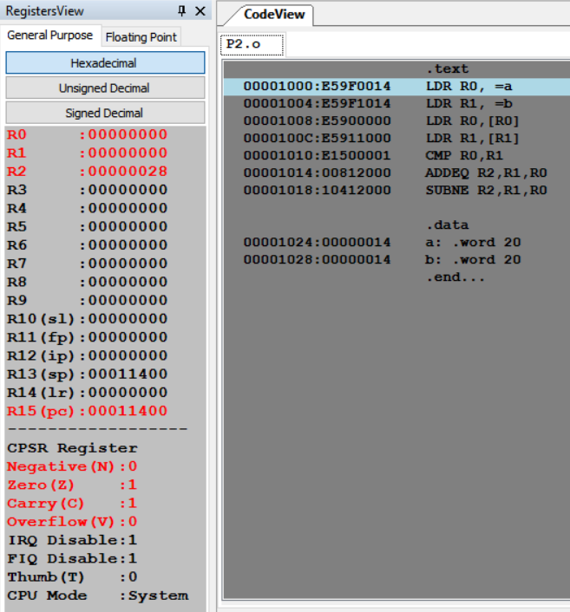 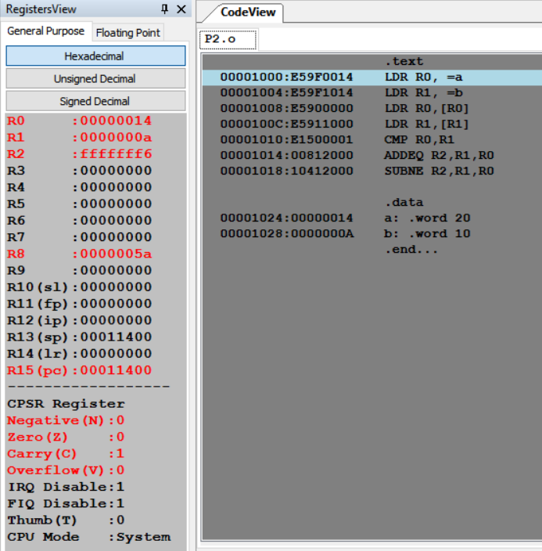

The output should be verified for both equal and nor equal values

**Microprocessor and Computer Architecture**

**UE21CS251B**

**4th Semester, Academic Year 2022-23**

Date:

|  |  |  |
| --- | --- | --- |
| Name: Nikhil Girish | SRN:  PES2UG21CS334 | Section: F |

Week#____1_______ Program Number: ____3___

Title of the Program

**Based on the value of the number in R0, Write an ALP to store 1 in R1 if R0 is zero, Store 2 in R1 if R0 is positive, Store 3 in R1 if R0 is negative. (Program shown in class)**

I.ARM Assembly Code:

.text

LDR R0, =a

LDR R0, [R0]

CMP R0, #0

ZERO:

    BNE NEGATIVE

    MOV R1, #1

    B end

NEGATIVE:

    BPL POS

    MOV R1,#3

    B end

POS:

    MOV R1, #2

end:

.data

a: .word -2

.end

II. Output Screen Shot (Three): 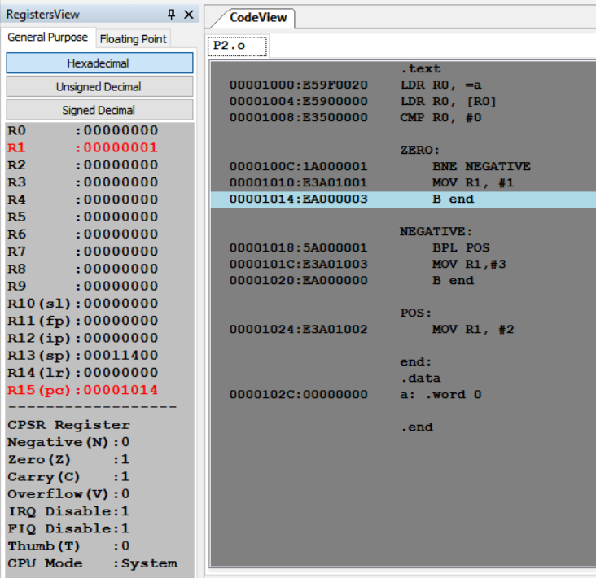 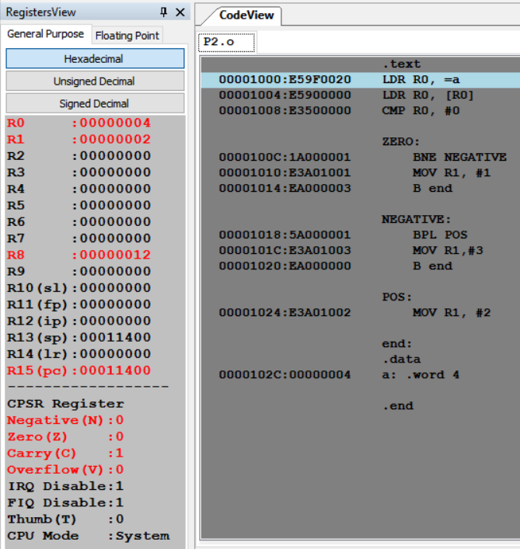

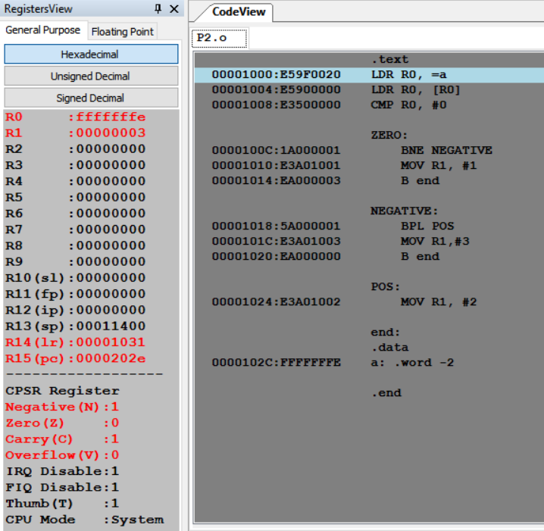

The output should be verified for zero, positive and negative cases.

**Disclaimer:**

* The programs and output submitted is duly written, verified and executed by me.
* I have not copied from any of my peers nor from the external resource such as internet.
* If found plagiarized, I will abide with the disciplinary action of the University.

Signature: 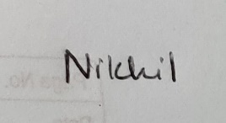

Name: Nikhil Girish

SRN: PES2UG21CS334

Section: F

Date: 23.01.2023